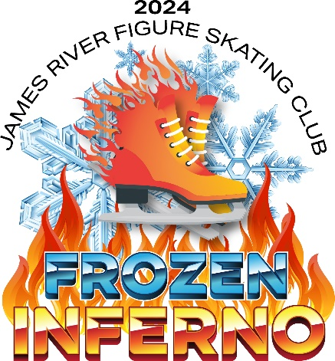
Frozen Inferno 2024 Cast List

Great Balls of Fire
In Summer
Madilyn Bear
Peyton Benson
Soren Boom
Keigan Carr
Jayla Mazur
Sophie Michel
Calyssa Miller
Cora Miller
Grant Patrick
David Peterson
Harper Rode
Georgia Schmeichel
Alivia Schulz
Bayleigh Steybe
Ashlynn Tritschler

Walking on Sunshine
Firework
Harper Ackland
Aleeah Albrecht
Hayden Boechler
Madelyn Holdburg
Berkley Kuss
Jozie Mazur
Violet Olson
Aubrey Roth
Daniel Peterson
Greta Sandland
Ring of Fire
Feeling Hot Hot Hot
Althea Berkey
Brynlee Block
Quinn Carr
Milliana Colburn
Stella Fisher
Madelyn Martin
Hannah Nagel
Kadence Patrick
Jessica Peterson
Aubree Sabinash-Protextor
Sayble Simmons
Reagan Stafslien
Charlee Stork
Fiona Sundeen
Aubrey Williams
Aurora Yonick
Dakota Yonick

Start a Fire in My Soul
[Love Is Like A] Heat Wave
Evelyn Brunner
Gwyndolin Cramer
Cadence Eagleson
Alexis Fettig
Alice Perleberg
Athena Su
Hailey Van Hall
Adelle Westerhausen
Cold As Ice
California Dreamin’
Clara Hanson
Kinsley Holub
Teagan Holub
Sammie Kolden
Adelyn Martin
Jenna Mazur
Berkleigh Mortenson
Elli Naasz
Zoey Norman
Maci Ogren
Ellianna Rostenbach
Katie Ryan
Addison Steckler

Spice Up Your Life
Clara Hanson
Kinsley Holub
Teagan Holub
Adelyn Martin
Jenna Mazur
Berkleigh Mortenson
Zoey Norman
Maci Ogren
Ellianna Rostenbach
Katie Ryan
Addison Steckler

The Heat Is On (Opening)
Freeze Frame (Closing)
Brinley Bear
Jacie Bear
Peyton Brunner
Coley Eagleson
Keira Lambrecht
Synneva Sortland
Gabby Tweten
Siri Tweten

Ice Ice Baby
(w/Hockey Skaters)
Keira Lambrecht
Synneva Sortland
Gabby Tweten
Siri Tweten
Tyson Jorissen
Cooper Kirkeby
Grant Lunde
Adam Sortland

Girl On Fire
Brinley Bear

Cold
Jacie Bear

Here Comes the Sun
Peyton Brunner

Hot N Cold
Coley Eagleson

Summer Nights
Keira Lambrecht

House of the Rising Sun
Synneva Sortland

Senior Solo
Gabby Tweten

Into the Unknown
Siri Tweten

